**Save Office 365 email attachments to OneDrive for Business**

In this lab, you'll see save Office 365 email attachments to OneDrive for Business using Power Automate.

It can be time consuming to search for attachments through email. The flow that you'll build saves time by storing all your email attachments in a folder on your Microsoft OneDrive for Business account.

## Choose a template

Sign in to [Power Automate](https://ms.flow.microsoft.com/), and select the **Templates** menu. You can sign up for Power Automate with a Microsoft account.

Select the **Save Office 365 email attachments to OneDrive for Business** template.

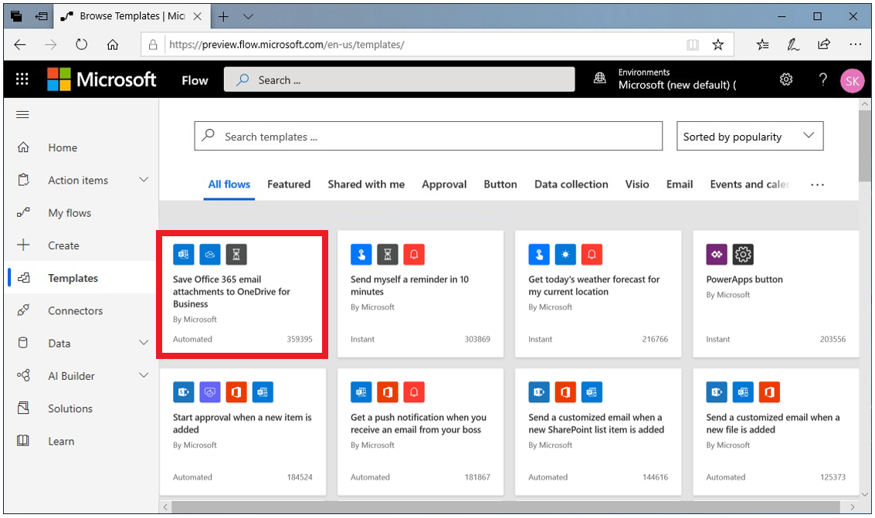

## Create the flow

1. Click on the template and select **Create Flow**.
2. On the next page, Power Automate creates the flow for you.
   * It will connect to your work email to get any attachments.
   * It will then create a folder on your OneDrive for Business account to automatically put every attachment that's sent to your work email address in that folder.

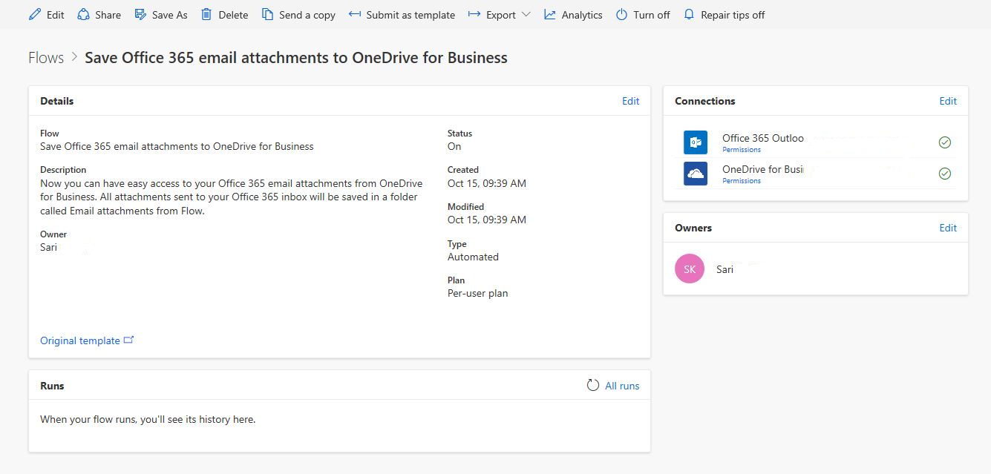

1. Select the **My flows** menu.
2. Select the flow you just created and click **Edit** to see how it works.

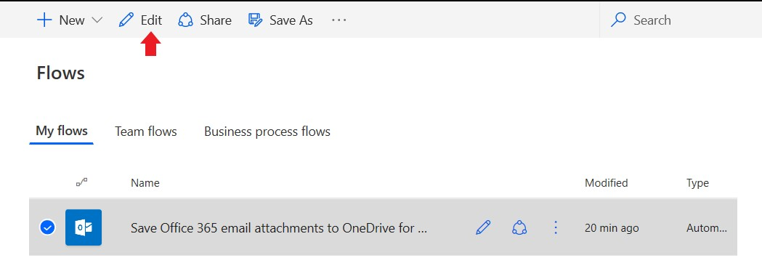

1. Send an email with an attachment, or have another user send an email with an attachment. You then should see a green check mark, which indicates that the flow succeeded.
2. Select the arrow towards the top to go back to the flow definition page.
3. The run history and the results are listed below.

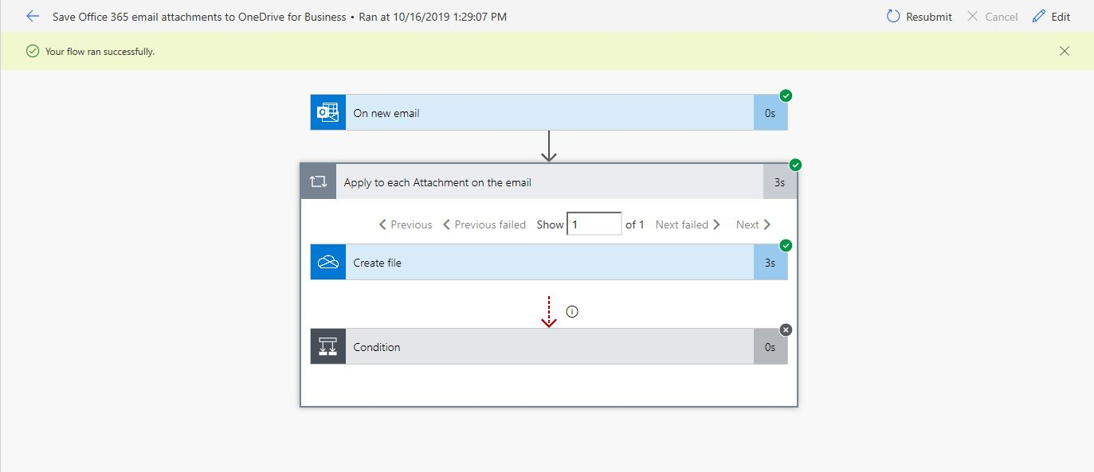

In this case, all parts of the flow were successful.

